

**TRIBHUVAN UNIVERSITY**

**INSTITUTE OF ENGINEERING**

**CENTRAL CAMPUS, PULCHOWK**

**DEPARTMENT OF ELECTRICAL ENGINEERING**

**LALITPUR, NEPAL**

A

FINAL YEAR PROJECT REPORT

ON

**“DESIGN AND FABRICATION OF THREE PHASE FOUR WIRE SHUNT ACTIVE POWER FILTER FOR POWER QUALITY ENHANCEMENT”**

(In partial fulfillment of B.E. in Electrical Engineering)

**EE755**

**PROJECT SUPERVISOR**

Assoc. Prof. Dr. Netra Prasad Gyawali

**PROJECT MEMBERS**

Rabin Subedi (068/BEL/326)

Sangit Poudel (068/BEL/331)

Sanij Gyawali (068/BEL/332)

Tulsi Sapkota (068/BEL/348)

September 2015

**COPYRIGHT**

The authors have agreed that the Library, Department of Electrical Engineering, Central Campus Pulchowk and Institute of Engineering may make this report freely available for inspection. Moreover, the authors have agreed that permissions for extensive copying of this project report for scholarly purpose may be granted by the supervisors who supervised the project work recorded herein or, in their absence, by the Head of Department wherein the project report was done. It is understood that the recognition will be given to the authors of this report and to the department of Electrical Engineering, Central Campus, Pulchowk and Institute of Engineering in any use of the material of this project report. Copying or publication or the other use of this report for financial gain without approval of the Department of Electrical Engineering, Central Campus Pulchowk and authors’ written permission is prohibited.

Request for permission to copy and make any other use of the material in this report in whole or in part should be addressed to:

The Head

Department Of Electrical Engineering

Central Campus, Pulchowk

Lalitpur, Nepal

**ACKNOWLEDGEMENT**

At first, our humble gratitude goes to our project supervisor **Assoc. Prof. Dr. Netra Prasad Gyawali** for guiding us throughout this project**.** His valuable advice, suggestions, instructive guidance and cooperative supervision has been one of the motivating factors for the successful completion of the project with ease.

We would like to express our honor to the Department of Electrical Engineering for providing us the opportunity to do a final year project on the topic of interest.

We would also like to thank **Assoc. Prof. Dr. Nava Raj Karki,** Head of Department, for his support with provision of the lab facilities and other electrical equipment required for the project. We would also like to thank our respected **Prof. Dr. Indraman Tamrakar** for initiative guidance of the project.

At last, we’d like to thank to all our teachers, colleagues and seniors especially to **Mr. Dipesh Shrestha,** for their support throughout the project.

**ABSTRACT**

This project report presents a three phase four wire shunt active power filter (SAPF) which automatically adapts to changes in the network and load fluctuations in electrical

systems to mitigate power quality problems by the use P-Q theory as control strategy. The power stage of the SAPF is based on a three phase inverter, with two split phase capacitors in dc side, and three filter inductors in the ac side. It can be used for the compensation of harmonic components of current drawn by the non-linear load, compensation of reactive power and compensation of unbalance loading condition.

Shunt active power filter operates as a current source injecting the current harmonics drawn by the load and letting the source to supply only the fundamental component.

In this project, we have used three RL circuits with o.1H inductance in series with 5, 10 and 15 ohm resistances respectively connected across each rectifier for the purpose of non-linear load and are powered by three phase 8V ac through three phases Variac connected from grid. Likewise, we have modeled digital Butterworth filter using MATLAB and designed using a microcontroller and finally required current is injected by inverter through three coupling inductors with 2 mH inductance.

First of all we have modeled the overall system in the MATLAB/SIMULINK. And then

for the hardware fabrication we first designed different circuits in the Proteus. And

finally we fabricated the system in the PCB.

In MATLAB simulation, we found that the THD of the system is improved from

45% to almost 5% after the use of the system. In hardware, we successfully calculated

the reference current and manually injected the current through 3- phase inverter.

**CONTENTS**

**COPYRIGHT....................................................................................................................... i**

**ACKNOWLEDGEMENT ................................................................................................... ii**

**ABSTRACT ........................................................................................................................ iii**

**CONTENTS......................................................................................................................... iv**

**LIST OF FIGURES ........................................................................................................... vi**

**LIST OF ACRONYMS ...................................................................................................... viii**

1. **Introduction………………………………………………………………………………………………………..1**
   1. background
   2. Existing issues /rational of study,
   3. literature survey
   4. objective and scope of study
   5. Report layout
2. Methodology
   1. project layout (system description, rating, size)
   2. system components
      1. components1
      2. component 2
      3. ..
   3. proposed control/operation schemes (use equation editor , standard figure by own, use same notation throughout the report; in figure, equation, text)
   4. computational model
3. Simulation result (explain briefly about the software platform you use, solver model, simulation time frame , assumptions and cases before starting actual results
   1. cases 1
   2. cases 2
   3. …
   4. …
   5. Summary
4. hardware description (describe about the hardware feature, size, rating, whether it is scalable or not)
   1. components
   2. ..
   3. ..
   4. results
5. Conclusion
6. Reference ( cite each reference in the text)
7. Annex

**LIST OF FIGURES**

Fig. 2.1 Overall Implementation of Proposed Scheme.............................................................. 4

*Fig 2.2 characteristics of (a) linear load (b) non-linear load…………………………………..*

**LIST OF ACRONYMS**

AC Alternating Current

SAPF Shunt Active Power Filter

Hz Hertz

PCB Printed Circuit Board

V Volt

H Henry

THD Total Harmonic Distortion

Y-n Star connection with neutral

Dc Direct Current

P-Q Instantaneous power

Strategy

**1. INTRODUCTION**

**1.1. Background**

Power electronics based loads which are used intensively in present scenario has produced an adverse impact on the quality of electric power supply. Both high power industrial loads and domestic loads introduce harmonics in the power network, additionally excessive reactive power is consumed by such loads resulting large line loss.at the same time, many equipment are sensitive to the deviation from the ideal sinusoidal line voltage when exposed to such disturbances.

The presence of harmonics in the power lines results in greater power losses in distribution, interference problem in communication systems and, sometimes in operation failure of electronic equipment, which are more secretive since they include microelectronic control systems, which work with very low energy levels. Because of these problems, the issue of the power quality delivered to the end consumers is of great concern.

**1.2. Rational of study**

The problem of harmonic distortion conventionally was dealt with the use of passive LC filters. In spite of some promising features of these passive filters like simple and easy design, low initial cost and average compensation these filters suffers from the problems like dependency of filtering characteristics upon source impedance and topology, parallel resonance problem, the response provided is static i.e. depends on load and very limited frequency compensation.

Nowadays the power network has become more and more complex, different types of load are being added in the system, the system load no longer remains constants, they are changing in every second, power electronic based loads are emerging day by day. So for the satisfied level of harmonic compensation there is a need of sophisticated and flexible compensating mechanism with dynamic response and satisfying degree of compensation. The appropriate scheme is Active power filter also called active power line conditioner. These are able to do the processing in time domain so are able to compensate in transient as well steady state. With the help of Active power filter we can compensate harmonics as well reactive power in both balanced as well unbalanced loading. The additional advantage of using this scheme is that filtering automatically adapts to change in the network and load fluctuations.

In our project we are fabricating Shunt Active Power filter in hardware. Our project work can be relevantly used in various load centers where non-linearity is the major problems, where there are excessive inductive loads for reactive power compensation as well solve the problem of harmonics.

**1.3. Literature review**

The concepts of electric power systems under sinusoidal ac conditions have been well defined and accepted as a worldwide. However, under non-sinusoidal conditions several and different power definitions (theories) are in progress, as conventional concepts of power definitions lose their usefulness under non-sinusoidal domains.

Three phase circuits are often analyzed as a sum of three separate single phase circuits. The total active, reactive and apparent powers in three phase circuits have been calculated just as three times the power in a single phase circuit, or the sum of the powers in the three single phase, separated circuits. This is not good simplification, especially in case involving power electronic devices i.e. non- linear loads and when the loads are balanced. When there are non-linear and unbalanced load, analysis of three phase system from conventional power theory is cumbersome and difficult, whereas hold good result in balanced linear system.

The speed response of the non –linear loads and the way they generate reactive power and harmonic components have made it clear that conventional approaches to the analysis of power are not sufficient in terms of taking average or *rms* values of variables. Therefore, time domain analysis has evolved as a new manner to analyze and understand the physical nature of the energy flow in a non- linear circuit. In time domain analysis, there are lots of theories that describe the power flow problems with different approaches like instantaneous p-q theory, synchronous detection algorithm method, constant active power algorithm, fictitious power compensation algorithm, synchronous frame based algorithm etc. .

Among them instantaneous p-q theory is simple to apply as well gives satisfactory result under distorted and undistorted source voltage. By using these SAFP designed here uses this theory to develop the control algorithm.

**1.4. Objective and Scope**

The objective of our project work is to design and fabricate three phase four wire shunt active power filter for power quality enhancement using PQ theory in control strategy. To achieve the objective of the project, the MATLAB Simulink modeling of the system with designed parameters, PROTEUS simulation followed by bread boarding and debugging is performed. And finally PCB of the system is fabricated.

The scope of work is based on the objective above and follows as

* Description of overview of power quality with regard to harmonics, understanding the impact of non-linear loads on power system, and need for harmonic compensation
* A survey on active power line conditioning methodologies w.r.t ratings, configurations, power circuit topologies and compensation objectives etc.
* Development and designing of a control algorithm for harmonics extraction and compensation of reactive power based on the p-q theory
* Control of DC bus voltage of the compensator to have correct control of the compensator
* Understanding and impact of AC link reactor on active filtering
* Development of the simulation of the whole system using MATLAB/Simulink as a simulation tool to investigate the role of SAPF for the compensation of harmonic and reactive power of the system
* Comparison and debugging i.e. comparison of the results obtained from hardware prototype with that of Simulation models and making necessary correction.

**1.5. Report Layout**

This report basically contains following main topics:-

**2. METHEDOLOGY**

The whole project work consists of simulation, software and hardware works. First of all we did perform is literature review of papers and articles in international and national magazines that boosted us in the theoretical aspect of SAPF and develop our own strategy to meet our project objective. After general planning of the strategy, we developed the simulation model of SAPF in MATLAB Simulink. After that was the hardware simulation model of the system in PROTEUS along with microcontroller programming in Aurdino 8Mega IDE. Before designing the PCB of the purposed scheme the hardware circuit was assembled and debugged in breadboard.

**2.1 Purposed System Layout**

SAPF that we’ve purposed is used for the compensation of harmonic components of current drawn by non- linear load. SAPF acts as the current source injecting harmonic component of load. It compels source to supply only fundamental component of load current under both balanced as well as un-balanced case. According to our scheme in Fig.2.1, the load current in each phase is sensed by Hall Effect current sensor which gives the output scaled voltage as the exact replica of the sensed load current. Here we are working under balanced and un- distorted source voltage so the source voltages (Va,Vb,Vc)is also sensed. Both the outputs from current sensor and voltage sensor are fed to the microcontroller through the ADC. Microcontroller is the main component of control block.

The instantaneous value of load current and source voltage which are fed into microcontroller are used to calculate instantaneous active and reactive power using PQ theory. Filtering is done in the power calculated by the digital filter designed within Microcontroller. The filtering process separates the oscillating active power component and total reactive power component and the reference currents are generated using inverse of PQ theory. The reference current is fed to ADC which converts digital reference current signals into analog voltage signal. Then after the reference current signals and injected current signals are compared and the gate signals are generated accordingly to trigger the Inverter MOSFETS. The gate signals are generated by hysteresis band current controller after comparison. The possible harmonics from inverter output if filtered through coupling inductors and connected to PCC.

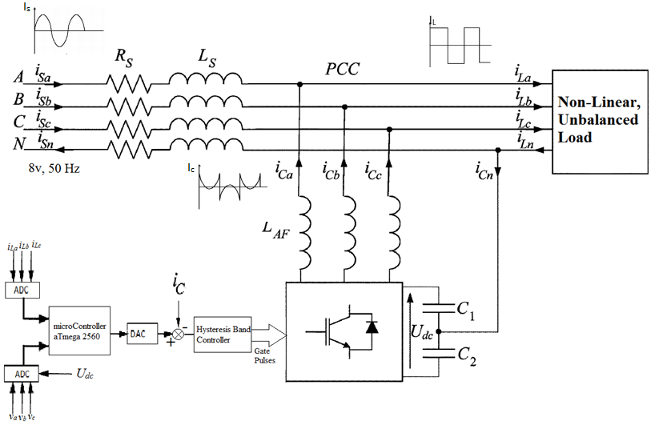

*Fig. 2.1 Overall implementation of Proposed Scheme*

**2.1.1 Introduction to loads**

There are generally two types of loads namely linear and non- linear loads. Linear loads draw load current which has waveform exactly similar to that of sinusoidal voltage. So, if the supplied voltage is composed of only fundamental component then the load current drawn will also contain only fundamental component as shown in *Fig 2.2(a).*But for the same voltage, non- linear load draws load current with fundamental along with harmonics component. Hence the resulting current drawn by such loads no longer remain sinusoidal as in *Fig 2.2(b)*.This deviation from a perfect sine wave can be represented by harmonics sinusoidal components having a frequency that’s is an integral multiple of fundamental frequency. To quantify distortion, the term total harmonic distortion (THD) is used. The term expresses the distortion as a percentage of the fundamental (pure sine) of voltage and current waveforms.

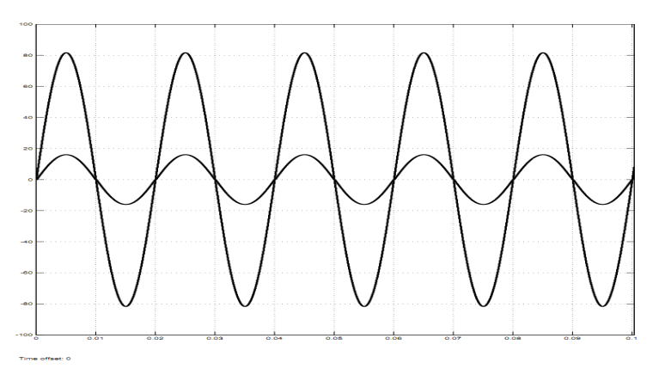 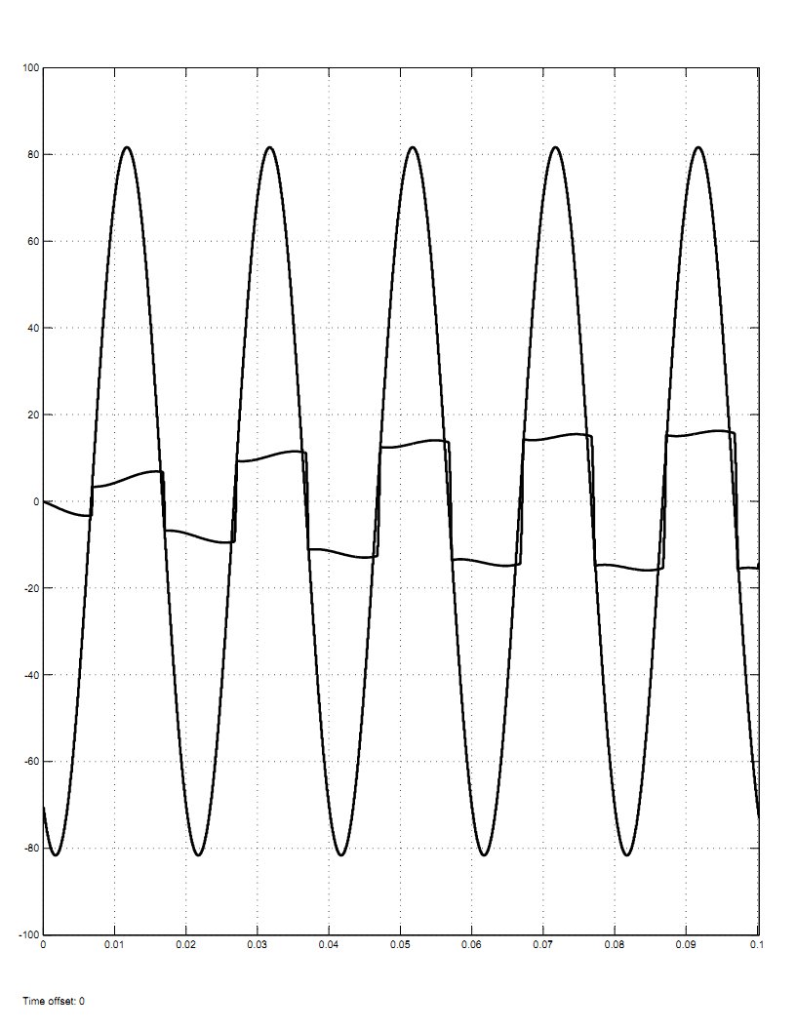

*(a) (b)*

*Fig 2.2 characteristics of (a) linear load (b) non-linear load*

**2.1.2 High pass filter**

In signal processing, signals are often encountered that contain unwanted information, such as random noise or interference, or there is need to selectively extract a signal of interest merged with several other signals. Filters are used in these situations to separate the signals of interest from others. High pass filter attenuates the signals having frequency lower than cut-off frequency whereas allows to pass signals with frequency larger than cut-off.

Filters can be analog or digital. Analog filters use electronic circuits made from components, such as resistors, capacitors, inductors and so on, to produce the required filtering effect. Whereas digital filter uses digital processer to perform filtering on sampled values of the signal. The processer may be a general purpose computing machine, such as PIC, AVR, FPGA or a specialized Digital Signal Processor (DSP) chip. At all stages, the signal being filtered is an electrical voltage or current.

The approach for the design of the high pass filter in our project is explained as below:

*a) Modeling of High pass filter*

Here we’ve selected second order Butterworth high pass filter. It has flat frequency response as possible in the pass band. It is also referred to as a **maximally flat magnitude filter**. In our project work we are filtering steady component of three phase power out from total power signal so the cut-off frequency for the filter is designed at ѡ=111.7323 rad/sec i.e.≈17.8Hz. The transfer function of such filter is:

G(s) = $\frac{s^{2}-2.476s+833.3}{s^{2}+158.1s+15700}$

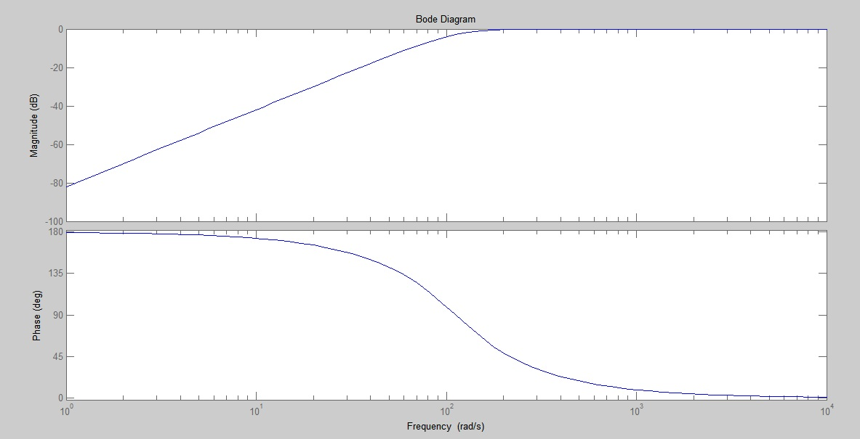

*b) Digital implementation*

Sampling is the main task for the digital filtering process. Sampling is the process of sensing the analog values at discrete time intervals. Whereas Quantization is the process of converting the sensed analog voltage to discrete values. Note that with quantization, the signal values are approximated to a finite set of values. The value obtained after sampling and quantization is referred to as a sample value. The sampling is done with certain condition that makes the discrete time interval sampling of continuous analog data precise and effective .That condition is Nyquist Sampling Criteria.

According to this criterion, if the signal has frequency components only up to a frequency of **F** Hz, then the signal must be sampled at **2F** frequency to prevent loss of signal information. After sampling and quantization, the signal is in the form of a sequence of numbers. The *Fig 2.4* shows thephenomena.

**ADC**

**Processor**

**DAC**

Filtered analog signal

Digitally filtered signal

Sample Digitized signal

Unfiltered Analog signal

*Fig 2.2 Signal processing using digital filter*

Following steps are followed to design a digital filter:

* The transfer function G(s) of analog filter is derived form required specifications.
* The transfer function G(s) is converted into Z domain G(z),which represents Z transform of transfer function of desired filter.
* Inverse Z transform of G(z) is taken which gives output equation on each sampled input data

The conversion from S domain to Z domain can be done by any of the following methods:

* Impulse Invariant
* Step Invariant
* Bilinear Transformation
* Matched Z

The bilinear transformation (also known as Tustin’s method) is used in digital signal processing and discrete-time control theory to transform continuous-time system representations to discrete-time and vice versa. This method is simple and easy than other methods. According to Bilinear transformation technique the term ‘s’ in G(s) is replaced with the ‘z’ expression as shown below, to create the transfer function of digital filter,

S= $\frac{2(z-1)}{T(z+1)}$

Where, T=sampling period satisfying the Nyquist Criteria

Now, for bilinear transformation, taking sampling frequency of 3K Hz and then substituting

S= $\frac{2(z-1)}{T(z+1)}$ at T=1/3000 sec,

We’ll get

G (z) = $\frac{z^{2}-1.999z+0.9993}{z^{2}-1.947z+0.9487}$ = $\frac{Y(z)}{X(z)}$

After some manipulation and taking inverse Z-transform, the required difference equation is,

**Y (k) =x (k)-1.999x (k-1) +0.999x (k-2) +1.947y (k-1)-0.9487y**

Where, k=n*T n=0, 1, 2, 3

y (k) =output of kth instant

y (k-1)=output of( k-1)th instant

x (k) =input of kth instant

x (k-1) = input of (k-1)th instant

Hence we got an equation according to which output at an instant depends upon input at that instant, previous inputs and outputs.

**2.1.3 Hysteresis band current controller**

It is an instantaneous feedback current control method in which a band is created around a reference current. The reference current is the required current that is expected to be injected ideally. The hysteresis band provides boundary around reference within which the injected current is made to fluctuate as in the *Fig 2.5.* This is achieved by controlling the gate signal of the inverter.

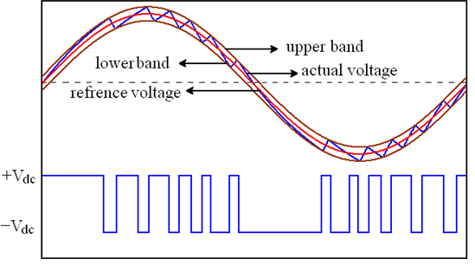

*Fig 2.5 Hysteresis band current control scheme*

A comparator is used to compare the value of actual signal and the reference signal to give gate signal as output. Normally, to control the value of some signal, one of the approaches is to use a single threshold value i.e. with no band around the reference signal. In that case, as the actual signal crosses the reference signal, the output gate signal varies as shown in *Fig 2.5(a).*Another approach is to create an upper and lower threshold around the reference signal, thus obtained output gate signal is as in *Fig 2.5(b).*The latter scheme has less oscillating gate signal than in first one. Since the gate signals are steady and does not changes instantly second scheme is used in hardware.

*(a) (b)*

*Fig 2.5 Comparator output circuit with single & double threshold*

**2.1.4 Control scheme**

Under this scheme, the load current and voltage are sensed from each phase (*abc*) and are sent to microcontroller, where abc voltages and currents are converted into αβ0 parameters by the use of Clarke’s transformation. These αβ0 parameter are used to calculate instantaneous Active power (**p**), instantaneous reactive power (**q)** using p-q theory .By selecting the power to be compensated, the reference current is extracted and is fed to the hysteresis band controller.

*a) Introduction to instantaneous p-q theory*

The p-q theory was introduced by Akagi, Kanazawa, and Nabae in 1983.This theory is based on a set of instantaneous values of active and reactive powers defined in time domain. There is no restriction on the voltage or current wave forms. Thus it is valid not only in the steady state, but also in transient state. The p-q theory first uses Clarke transformation to transform voltages and currents from the *abc* to αβ0 coordinates, and then defines instantaneous power on these coordinates. Hence, these theories always consider the three phase system as a unit, not a superposition or sum of three single phase circuits.

αβ0 are stationary reference axes .Since *ab* *c* axes are spatially shifted by 2π/3 rad from each other while α and β axes are orthogonal, and the α axis is parallel to *a*  axis. The direction of the β axis is chosen in such a way that if voltage or current spatial vector on the *abc* coordinates rotates in the *abc* sequence, they would rotate in the αβ sequence on the αβ coordinates.

*b) Reference current extraction*

For it firstly voltages (balanced in our case) and load currents in *abc* axes are transformed into αβ0 axes by using equations (1) and (2)

$\left[\begin{aligned}v_{0} \\ v_{α} \\ v_{β}\end{aligned}\right]$ = $\sqrt{\frac{2}{3}}\left[\begin{matrix}\frac{1}{\sqrt{2}} & \frac{1}{\sqrt{2}} & \frac{1}{\sqrt{2}} \\ 1 & \frac{-1}{2} & \frac{-1}{2} \\ 0 & \frac{\sqrt{3}}{2} & \frac{-\sqrt{3}}{2}\end{matrix}\right]\left[\begin{aligned}v_{a} \\ v_{b} \\ v_{c}\end{aligned}\right]$ (1)

$\left[\begin{matrix}i_{0} \\ i_{α} \\ i_{β}\end{matrix}\right]$ = $\sqrt{\frac{2}{3}}\left[\begin{matrix}\frac{1}{\sqrt{2}} & \frac{1}{\sqrt{2}} & \frac{1}{\sqrt{2}} \\ 1 & \frac{-1}{2} & \frac{-1}{2} \\ 0 & \frac{\sqrt{3}}{2} & \frac{-\sqrt{3}}{2}\end{matrix}\right]\left[\begin{aligned}i_{a} \\ i_{b} \\ i_{c}\end{aligned}\right]$ (2)

Load side instantaneous active and reactive power components are calculated by using voltage and current values on αβ0 frame as given in equation (3)

$\left[\begin{aligned}p_{0} \\ p \\ q\end{aligned}\right]$ = $\sqrt{\frac{2}{3}}\left[\begin{matrix}v_{0} & 0 & 0 \\ 0 & v_{α} & v_{β} \\ 0 & -v_{β} & v_{α}\end{matrix}\right]\left[\begin{matrix}i_{0} \\ i_{α} \\ i_{β}\end{matrix}\right] (3)$

Since, it is only concerning balanced and undistorted source voltage, the above equation reduces to

$\left[\begin{aligned}p \\ q\end{aligned}\right]$ = $\sqrt{\frac{2}{3}}\left[\begin{matrix}v_{α} & v_{β} \\ {-v}_{β} & v_{α}\end{matrix}\right]\left[\begin{aligned}i_{α} \\ i_{β}\end{aligned}\right] (4)$

The instantaneous active and reactive power consists of DC and AC component i.e. $P=\overline{P}+\tilde{P}$ and $q=\overline{q}+\tilde{q}$**.** DC component of ***p*** and ***q*** consists of the positive sequence components of fundamental load current, whereas AC component of ***p*** and ***q*** consists of harmonic and negative sequence of load currents. The objective of p-q theory is to get the source to give only the constant active power demand by the load so the power $\tilde{P}$ and ***q*** is compensated. High pass filter is used to separate the oscillating part of the active power and the reference current in *abc* phases are calculated using following two equations:

$\left[\begin{aligned}{i_{α}}^{ref} \\ {i_{β}}^{ref}\end{aligned}\right]$ = $\frac{1}{{v_{α}}^{2}+{v_{β}}^{2}}\left[\begin{matrix}v_{α} & -v_{β} \\ v_{β} & v_{α}\end{matrix}\right]\left[\begin{aligned}-\tilde{p}+{\overline{p}}_{loss} \\ -q\end{aligned}\right] (5)$

The signal ${\overline{p}}_{loss}$ from dc regulator block is also fed into this block which accounts for the power loss in capacitor during voltage fluctuation across the capacitor.

$i_{0}^{ref}=i_{0}$ from equation(2) since we have $v_{0}=0$

$\left[\begin{aligned}i_{a} \\ i_{b} \\ i_{c}\end{aligned}\right]$ = $\sqrt{\frac{2}{3}}\left[\begin{matrix}1 & 0 & \frac{1}{\sqrt{2}} \\ \frac{-1}{2} & \frac{\sqrt{3}}{2} & \frac{1}{\sqrt{2}} \\ \frac{-1}{2} & \frac{-\sqrt{3}}{2} & \frac{1}{\sqrt{2}}\end{matrix}\right]\left[\begin{aligned}{i_{α}}^{ref} \\ {i_{β}}^{ref} \\ {i_{0}}^{ref}\end{aligned}\right] (6)$

These reference current are fed in each phases by the power inverter in order to get complete compensation. After this source will be providing balanced steady power whereas the oscillating power is provided by inverter itself. The figure below shows the extraction scheme.

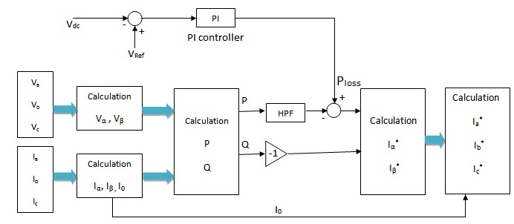

*Fig 2.6 Illustration of reference current calculation*

**2.1.5 Three legged power inverter**

For inverter configuration six switches forming three legs are used as shown in *Fig 2.7*. Here S+ and S- form one pair and remaining form another two pair. The configuration is maintained in such a way that if one of the switches is ON in any of the pair than another switch in same pair is OFF using NOT gate. The operating sequence of each leg differs by 120°.

At DC side of power inverter two split phase capacitors are used which acts as chargeable DC source. The three terminals *abc* in each leg are three phase output terminals of inverter whereas the point between two split phase capacitors is neutral point. Depending upon the ON-OFF sequences of switches negative as well positive DC voltage appears across these output terminals.

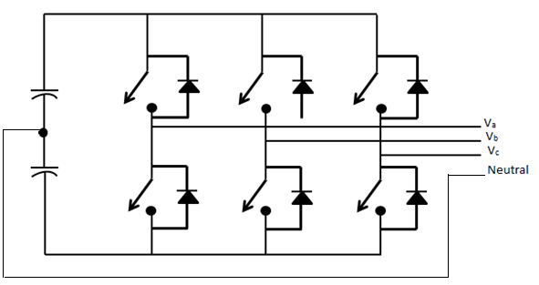

c

b

a

S3-

S2-

S1-

S3+

S1+

S2+

+

-

+

-

*Fig 2.7 Three phase inverter with split phase capacitor*

**2.2 MATLAB Simulation study/modeling**

MATLAB is a technical computing environment for high performance numeric computation and visualization. It is a technical computing environment for high performance numeric computation and visualization computing language developed by The Math Works Inc. MATLAB integrates numerical analysis matrix computation, signal processing, and graphics into an easy to use environment. The term MATLAB stands for Matrix Laboratory.

Simulink is a software package inside the MATLAB. Simulink and MATLAB form a package that serves as a tool for modeling dynamic systems. Simulink provides graphical user interface (GUI) that is used in building block diagrams, performing simulations, as well as analyzing results. Simulink includes a comprehensive block library of sinks, sources, linear and nonlinear components, connectors etc. Simulink provides the facility of customizing and creating our own blocks. Using scopes and other display blocks the simulation result can be observed and analyzed. In addition, the parameters of the model developed can be changed and observed immediately for ‘what if’ exploration.

**2.2.1 Three phase non- linear load**

Non-linear load is modeled in MATLAB/Simulink as shown in the *Fig 2.8*. It consists of three universal diode bridges with two arms between each phase and neutral line. The dc output of the bridge is fed to RL load. The values of R and L are selected such that overall three phase system will be loaded in unbalanced manner. The loads are modeled with following specification:-

*The Parameters Of Simulated Load*

|  |  |
| --- | --- |
| **Phase** | **Load** |
| A | (10Ω,0.1H) |
| B | (15Ω,0.1H) |
| C | (5Ω, 0.1H) |

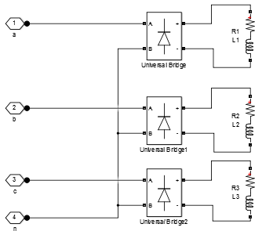

*Fig 2.8*. *Modeling of non-linear load under MATLAB/Simulink*

**2.2.3 Hysteresis current controller**

The block in Fig *2.8* generates the gate signals for the inverter, controlling the switching pattern of IGBT so as to generate the required current. The instantaneous injected current from the inverter (I_meas) and reference current generated (I_ref) is supplied as input in the block and accordingly hysteresis band of current is created. The block checks if injected current from inverter is within the limit of the band and produces corresponding output signal.

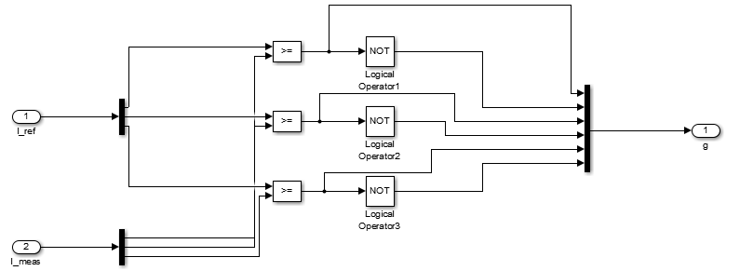

*Fig 2.9*. *Modeling of hysteresis current controller in MATLAB/Simulink*

It generates gate pulses by comparing reference current with actual current injected so basically it forms closed loop system and is precise. Thus, the current controller generates gate signals in following pattern:-

When I_ref>=I_ meas, output is 1.

When I_ref<I_ meas, output is 0.

Hence, comparators giving three outputs for three phases and logical inverter giving other three, total of six pulse signals are generated to drive IGBT switches.

**2.2.4 Dc voltage regulation block**

This block regulates the dc voltage at the dc side of the power inverter .The main component is the PI controller which generates the signal ${\overline{p}}_{loss}$.Here we wanted to maintain dc voltage by comparing it with a constant value Vref= 27v. If dc voltage i.e.Vdc1+ Vdc2 is less than Vref then it would create a positive ${\overline{p}}_{loss}$ signal and if dc voltage is greater than Vref it could create negative ${\overline{p}}_{loss}$ signal. The PI controller has the value of Kp=0.7 and Ki=1. *Fig 2.10* shows the Simulink block for dc voltage regulation.

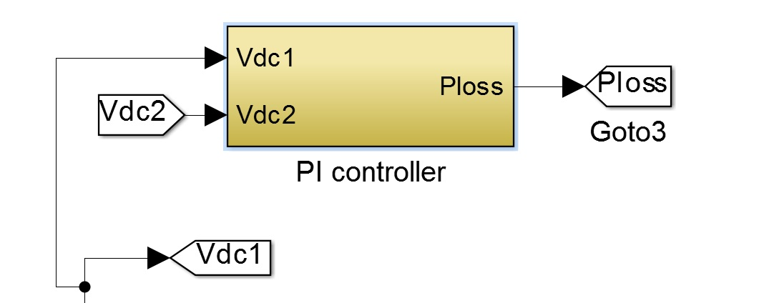 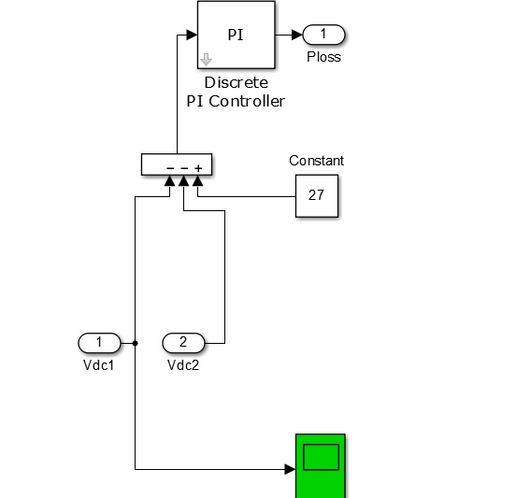

*Fig 2.10 MATLAB/Simulink model for dc voltage regulation block*

**2.2.5 Three phase inverter**

The Universal Bridge block implements a universal three-phase power converter that consists of six power switches connected in a bridge configuration. We are adopting IGBTs as power switches; below the *Fig 2.10* shows the IGBT Diode bridge configuration showing six IGBT switches. Their operation depends on the nature of gate pulse they receive. Anti-parallel connected diodes provide free willing path required in case of inductive load. Also, Q1Q2, Q3Q4 and Q5Q6 are complementary switches.

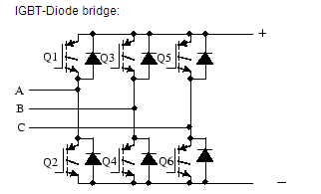  
*Fig 2.10(a) IGBT-Diode Bridge*

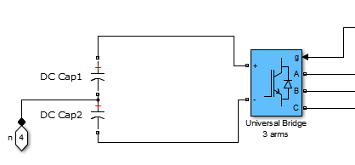

Gate pulses

Phase A

Phase B

Phase C

*Fig 2.10(b) Power inverter model under MATLAB/Simulink*

**2.2.6 p-q Calculation Block**

This block calculates the reference currents to be injected on the basis of instantaneous p-q theory. Whole block comprises of some MATLAB function block, Clarke transformation block and other calculation blocks. The voltage signals Va,Vb,Vc ,load current signals and ${\overline{p}}_{loss}$ signal from dc voltage regulation block are fed into this block where necessary calculation are done to generate reference currents(Icomp) depending upon the power selected to be compensated. Digital filter is also incorporated in it in order to filter the oscillating and steady state part of active power. *Fig 2.11* below shows complete model under MATLAB/Simulink.



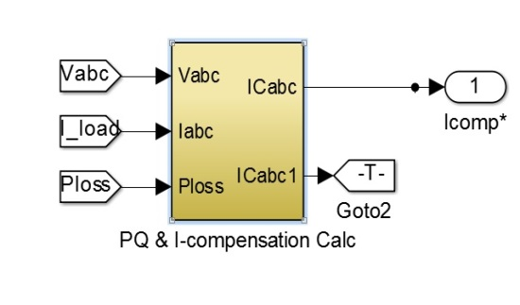

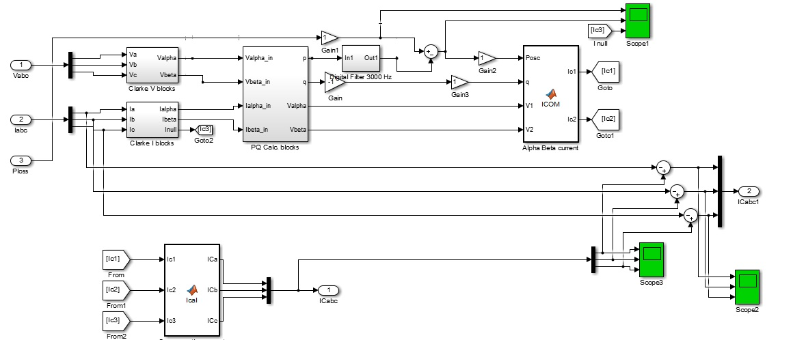

*Fig 2.11 P-Q and reference current calculation model under MATLAB/Simulink*

**3. SIMULATION RESULTS**

All the building blocks of Simulink as explained in previous section are integrated as

in Fig. 3.1 to form overall system. The scheme consist of generator modeled as an

AC voltage source of 400V, 50Hz with line resistance of 0.01 milli-ohm and line inductance of 1 micro-Henry which is supplying a non-linear load. Fig. 3.2 shows the SAPF model alone.

Below are the tables Specifying the simulated parameters:-

TABLE I

THE PARAMETERS OF SIMULATED SYSTEM

|  |  |
| --- | --- |
| Mains voltage per phase | 400v |
| Line frequency | 50Hz |
| Coupling Inductance | 2mH |

TABLE II

THE PARAMETERS OF SIMULATED LOAD

|  |  |
| --- | --- |
| **Phase** | **Load** |
| A | (10Ω,0.1H) |
| B | (15Ω,0.1H) |
| C | (5Ω, 0.1H) |

TABLE III

THE PARAMETERS OF PI CONTROLLER

|  |  |
| --- | --- |
| **Vref** | 1200 |
| Kp | 0.7 |
| Ki | 1 |

*A. Simulation Results without SAPF:*

Entire system is simulated to observe the nature of the current, active and reactive power drawn by the non- linear unbalanced load without connecting SAPF. The simulation results are shown in Fig.3.3 to Fig. 3.6. Fig. 3.3(a) shows the waveforms of line currents which are nearly square waves. Fig.3.4(a) shows the waveform of instantaneous active power. Fig. 3.5(a) shows the waveform of instantaneous reactive power. Fig. 3.6(a) shows the waveform neural current, which indicates that line currents are un-balanced.

TABLE IV

THD ANALYSIS WITHOUT SAPF

|  |  |
| --- | --- |
| Phase | THD% |
| A | 43.91% |
| B | 42.46% |
| C | 44.25% |

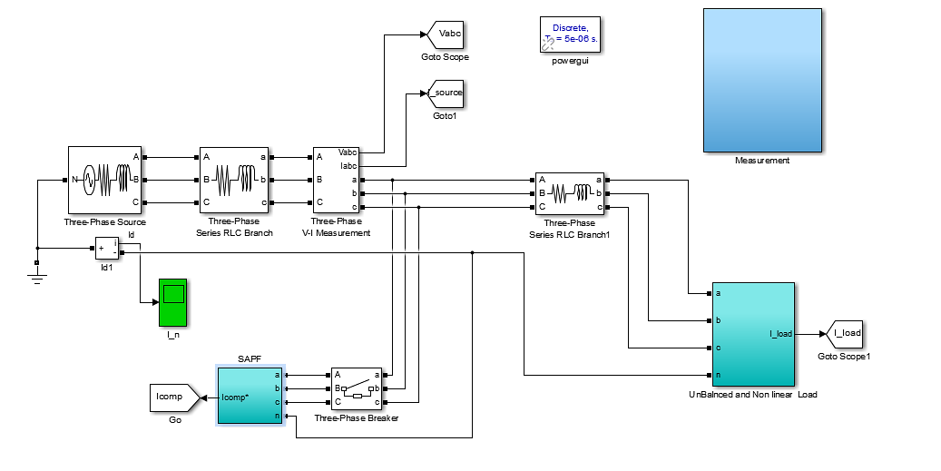

*Fig. 3.1 MATLAB/SIMULINK model of overall system*

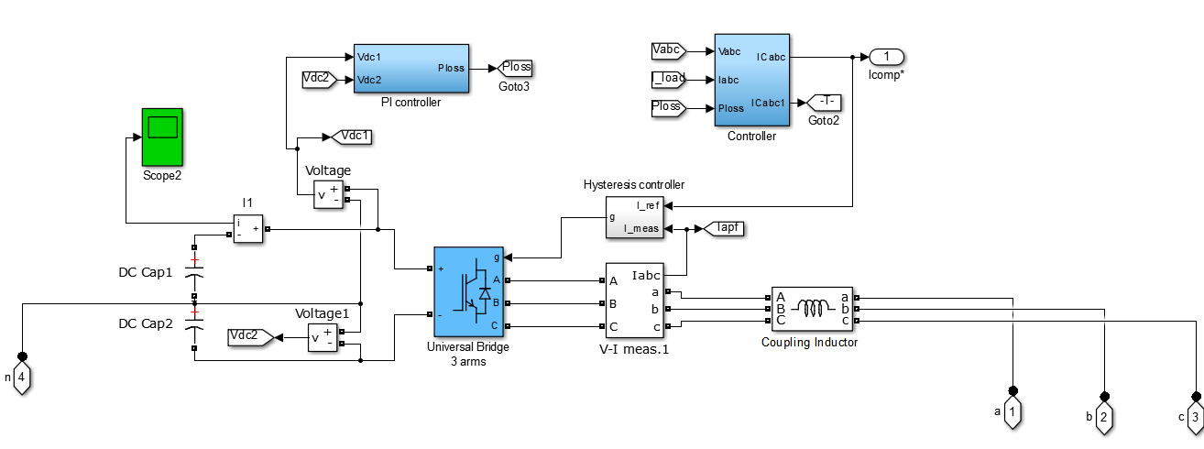

*Fig. 3.2 MATLAB/SIMULINK model of SAPF*

*B. Simulation Results with SAPF:*

Entire system with SAPF is simulated to observe the nature of the current, active and reactive power drawn by the non- linear unbalanced load. The simulation results are shown in Fig.3.3 to Fig.3.7. Fig. 3.3(b) shows the waveforms source currents of three phases, which are nearly sinusoidal. Fig. 3.4(b) shows the waveform of instantaneous active power. Fig. 3.5(b) shows the waveform of instantaneous reactive power. Fig. 3.6(b) shows the waveform of neutral current, which is nearly zero, which indicates that line currents are balanced. Fig 3.7 shows the waveform of compensating current injected into the system.

TABLE V

THD ANALYSIS WITH SAPF

|  |  |
| --- | --- |
| Phase | THD% |
| A | 4.88% |
| B | 4.99% |
| C | 4.22% |

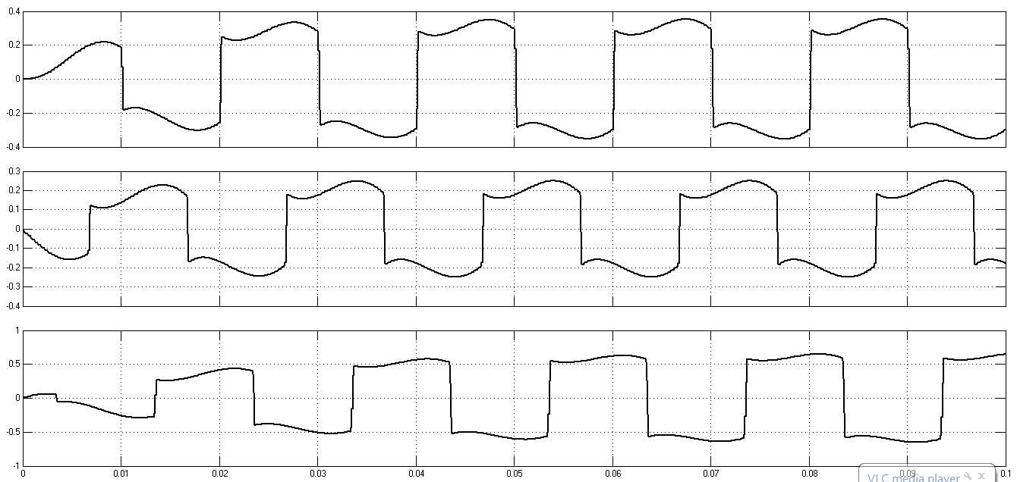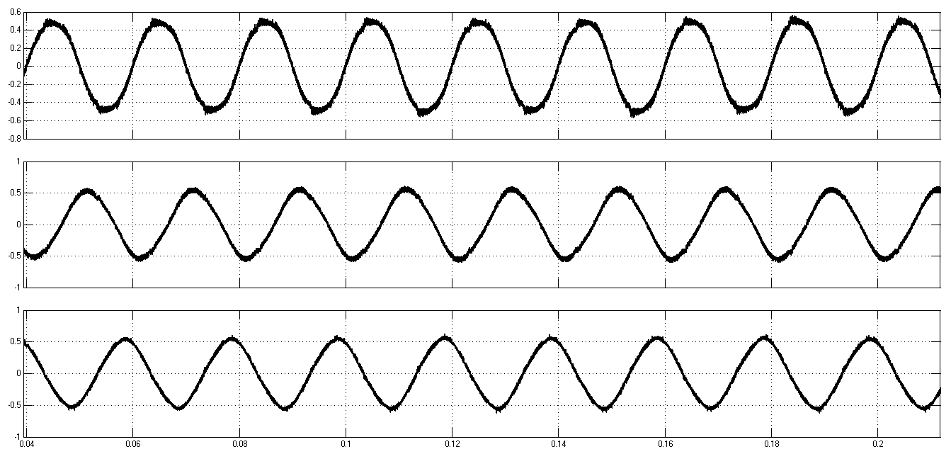

*(a) (b)*

*Fig. 3.3 Waveforms of three phase currents (a) Load Currents drawn by non-linear load*

*(b) Source currents after compensation*

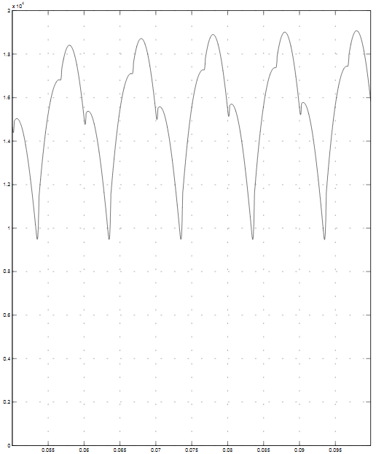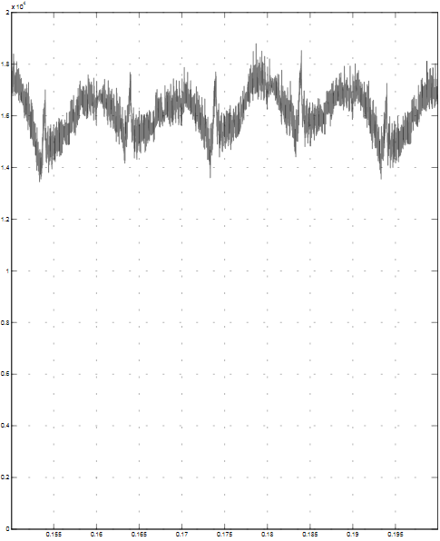

*(a) (b)*

*Fig. 3.4 Waveforms of instantaneous active power (a) before SAPF (b) after SAPF*

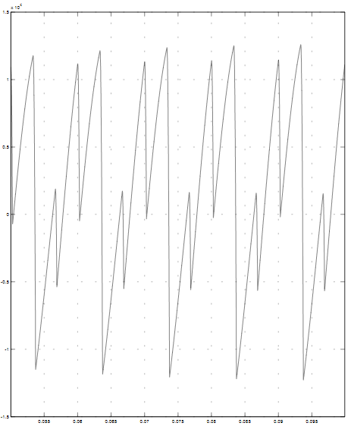

*(a)*

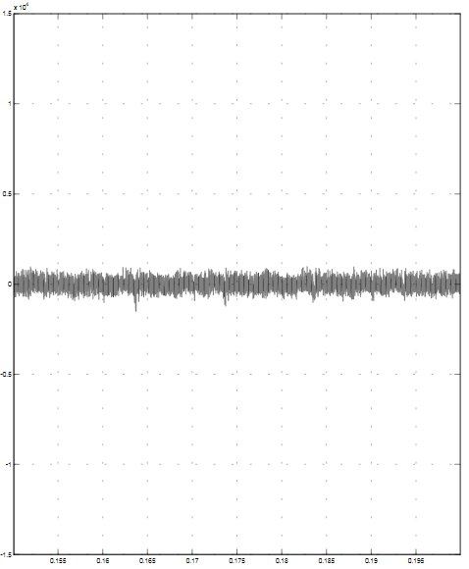

*(b)*

*Fig. 3.5 Waveforms of instantaneous reactive power (a) before SAPF*

*(b) after SAPF*

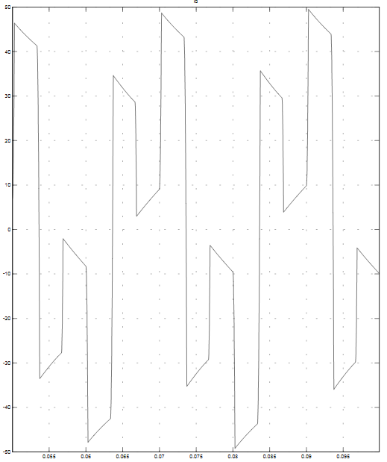

*(a)*

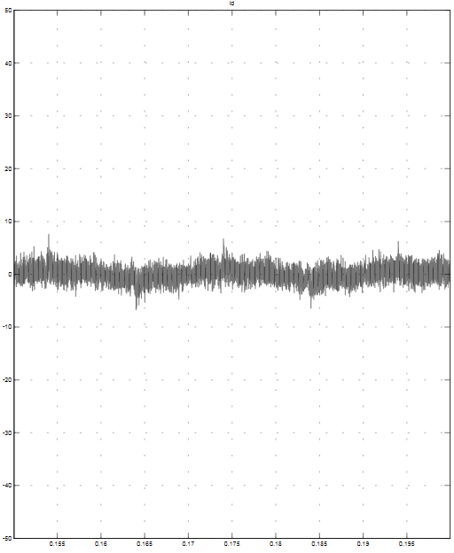

*(b)*

*Fig. 3.6 Waveforms of neutral cuurent (a) before SAPF*

*(b) after SAPF*

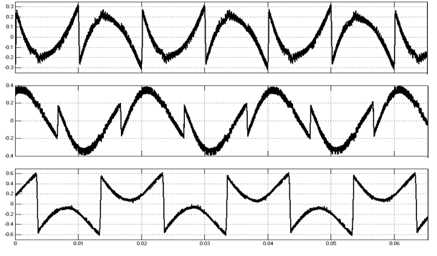

*Fig. 3.7 Waveforms of inverter injection currents*

**4. HARDWARE IMPLEMENTATION**

**4.1 Computational Tools**

These are computer software used to design, simulate, test and debug the hardware circuit .The computational tools used for hardware portion are mainly 2 types:

*a) Proteus 8 Professional:*

This one is the hardware to design and simulation circuits i.e. it is CAD software developed by Labcenter Electronics. Some of its features are

* Support for MCAD data exchange via STEP and IGES file formats.
* Import component STEP/IGES files for the parts in your project or describe them with a simple scripting language.
* Export the resulting STEP Assembly for loading into your MCAD tool of choice.
* Support for multiple track editing operations and enhancements to track necking.
* Enhanced support for design re-use via sub-circuit binding on the Replicate command.
* Addition of the MSP430G2X variant set and the PIC1845K50, together with the ILI9341 TFT display.

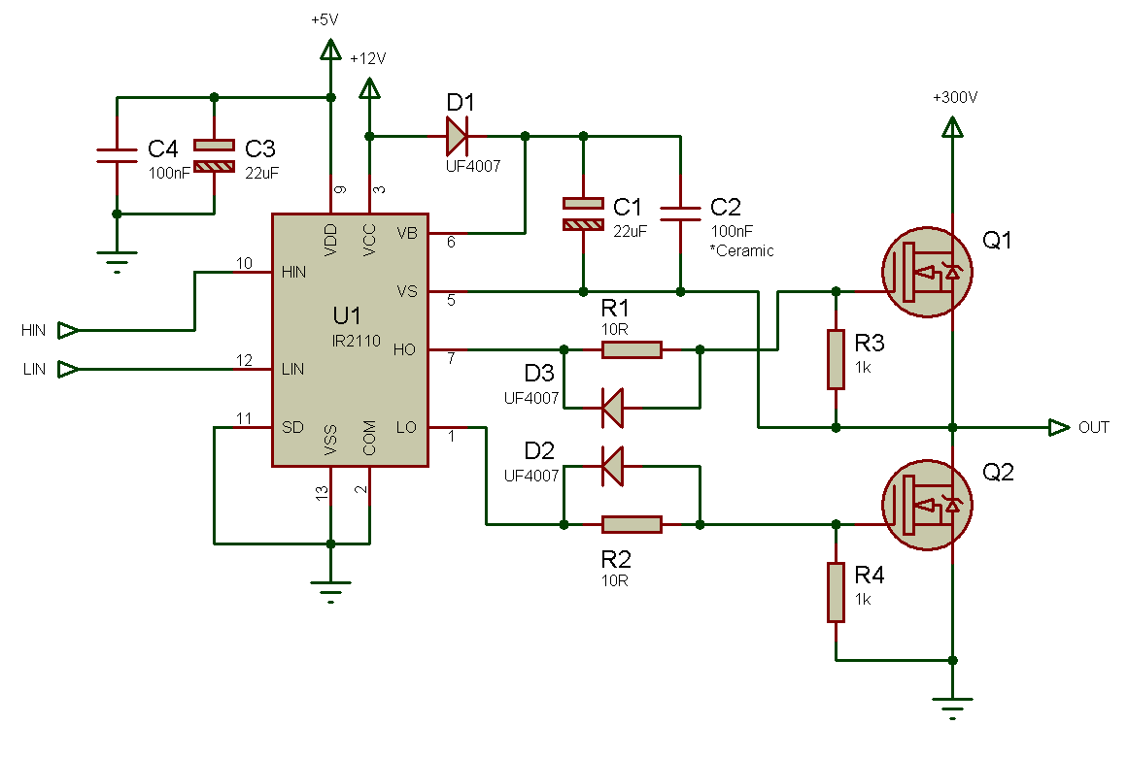

*Fig. 4.1 Circuit under PROTEUS*

*b)PCB Wizard:*

PCB Wizardis a powerful package for designing single-sided and double-sided printed circuit boards (PCBs).

It provides a comprehensive range of tools covering all the traditional steps in PCB production, including schematic drawing, schematic capture, component placement, automatic routing, and Bill of Materials reporting and file generation for manufacturing. In addition, PCB Wizard offers a wealth of clever new features that do away with the steep learning curve normally associated with PCB packages.

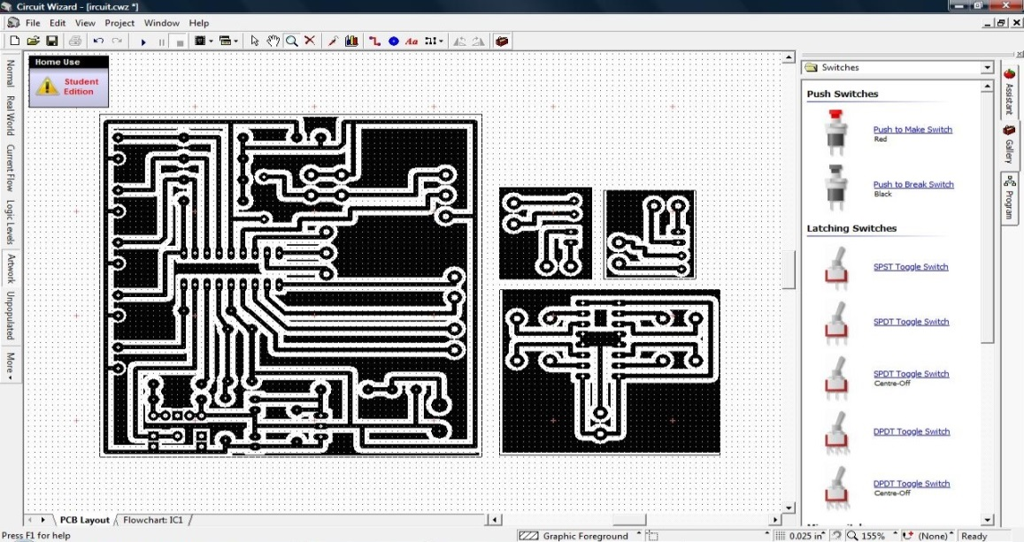

*Fig. 4.2 PCB layout design under PCB Wizard*

**4.2 Load fabrication**

Three phase non -linear load was modeled with the use of 3 single phase rectifier bridges on each phase followed by a RL load with inductance (L) = 0.1 H in each phase and resistance (R1) =5 ohm, (R2) =10 ohm and (R3) =15 ohm in three phases respectively. Fig. 4.3 shows the schematic diagram of load. The result showing current waveform of non-linear load is observed in actual hardware, Fig. 4.4 shows the current waveform of non-linear load on CRO.

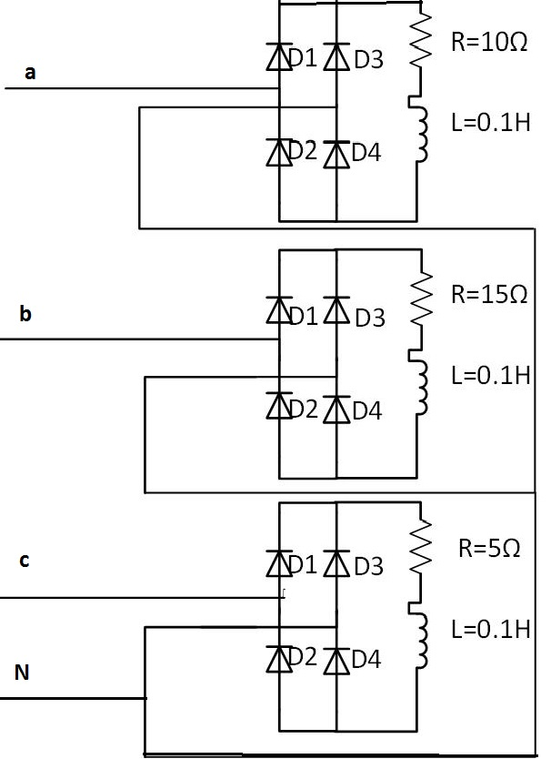

*Fig. 4.3 Schematic Diagram of three phase load*

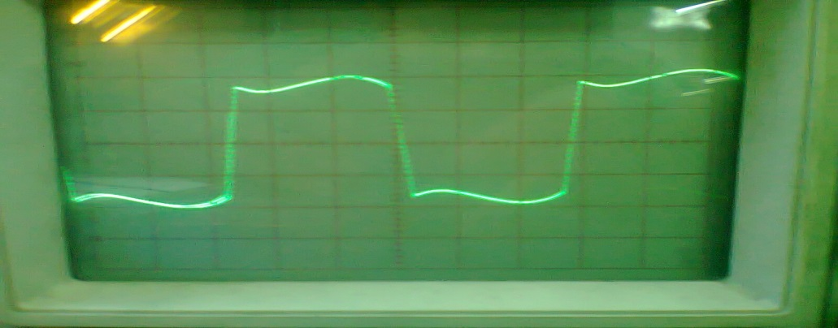

*Fig. 4.4 Current Waveform of Non-Linear load in actual hardware on CRO*

**4.2 Voltage Measurement**

AC voltage, greater than 5 V (peak), cannot be measured by the ADC of microcontroller directly. It will rather damage the microcontroller if done so. Hence the Voltage should be de-amplified in order to measure by using a microcontroller. It could be done either by a potential transformer or a difference amplifier. For low voltages difference amplifier will be economical.

Difference amplifier de-amplifies the voltage difference between phase and neutral as well as adds offset of 2.5 V in order to make the voltage signal suitable for measurement. Gain of difference amplifier could be adjusted according to requirement by selecting proper values of resistors. Hardware verification of the Voltage measurement circuit is done in PROTEUS as shown in *Fig. 4*.5 and *Fig. 4.6* shows the waveform of Input and Output voltage signal in Oscilloscope of Proteus.

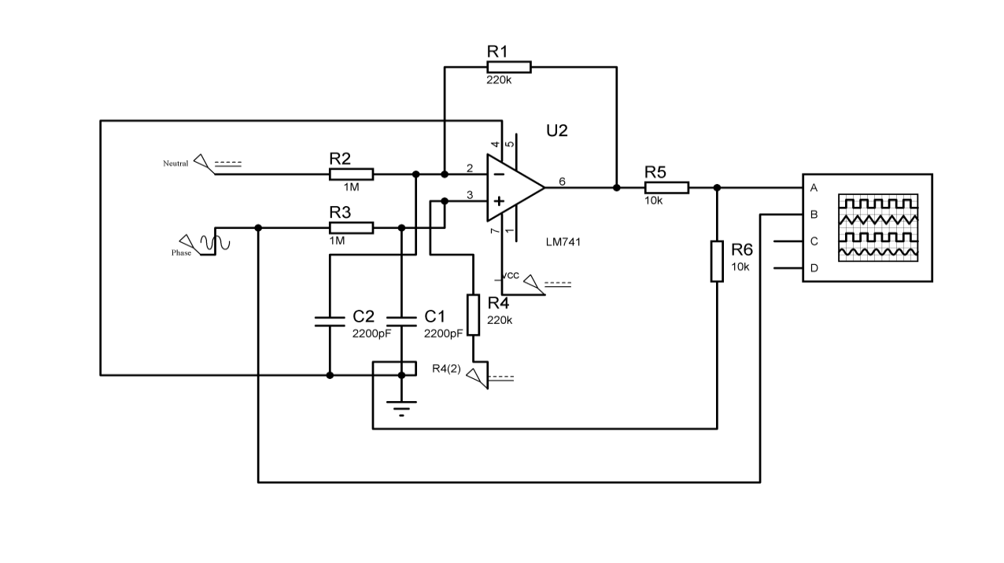

*Fig 4.5 Voltage Measurement circuit under Proteus*

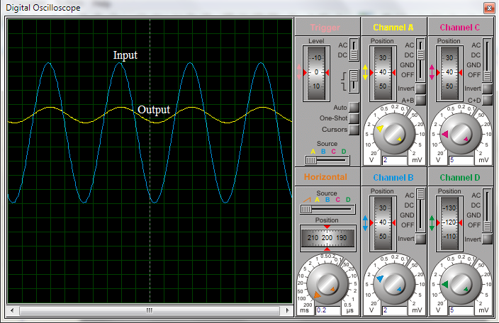

*Fig. 4.6 Waveform of Input and output Voltage signal*

**4.3 MICROCONTROLLER**

**4.4 DAC**

DAC stands for digital to analog converter. It is used to convert the digital data, either 1 (5 volts) or 0 (0 volts), to the corresponding analog value. The reference current signal obtained from the microcontroller, using the inputs and calculation, is in the digital form. Thus obtained digital data need to be converted into the analog voltage signal. For this purpose Digital to analog conversion IC, DAC 0808 is used as shown in Fig. 4.8. It is an 8 bit DAC, which means it takes 8 bit digital data and can have 28 different states. Its output is in the form of current signal. So, output current signal from the DAC is converted into the voltage signal using op-amp.

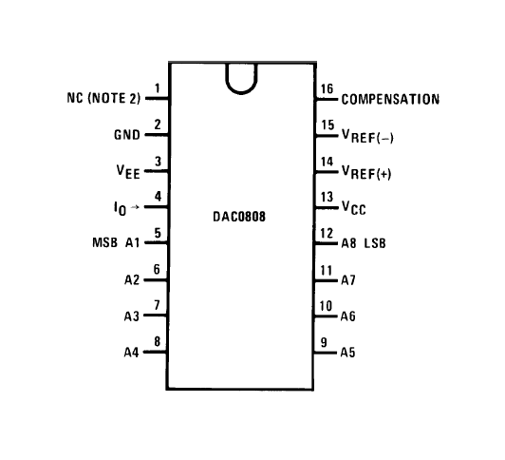

*Fig. 4.8 DAC 0808 IC Pin Configuration*

Fig. 4.9 illustrates the hardware model of a DAC circuit in PROTEUS. For the verification of model, digital input 11111111 and 00000000 is used alternatively whose analog output is 5 V and 0 V respectively as shown in Fig. 4.10.

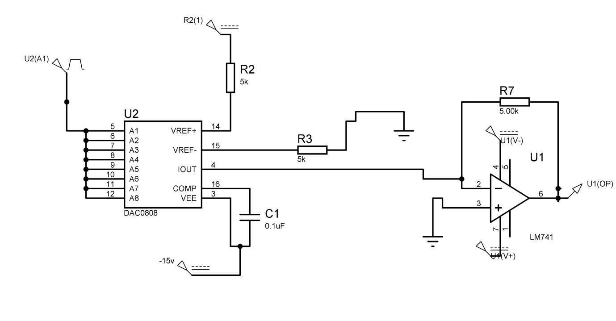

*Fig. 4.9 DAC in Proteus*

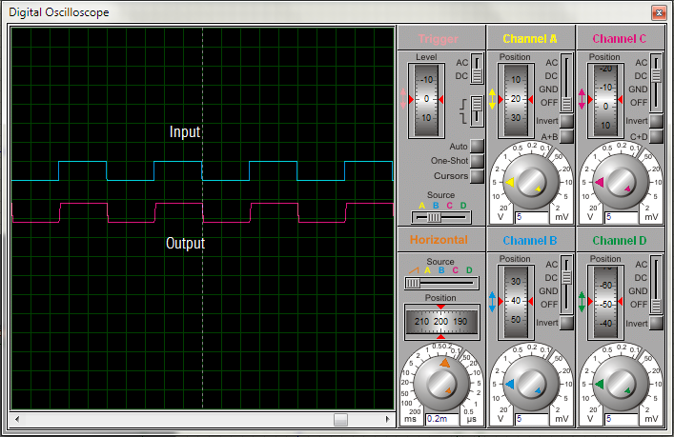

*Fig. 4.10 Output of DAC in Proteus Oscilloscope*

**4.5 HYSTERESIS BAND CURRENT CONTROLLER (SCHMITT TRIGGER)**

It is a circuit or system with positive feedback and loop gain greater than 1. It is called

“trigger” because the output retains its value until changes sufficiently to trigger a

change. In the non-inverting configuration, when the input is higher than a certain chosen threshold, the output is high. When the input is below a different (lower) chosen

threshold, the output is low, and when the input is between the two levels, the output

retains its value. This dual threshold action is called hysteresis and implies that the

Schmitt trigger possesses memory and can act as a bi-stable circuit (latch or flip-flop).

There are two threshold values in Schmitt trigger which are formed by adding certain

value to create upper threshold and subtracting same value to create lower threshold.

In this way a band is created around the reference signal in Schmitt trigger called as

hysteresis band. Thus, Schmitt trigger can be used to create a hysteresis band around

the reference signal and compare the actual signal such that the output changes its state

only when actual signal try to cross the band around the reference signal if the output

signal can control the actual signal behavior. This can be done if output is used as a gate

signal for the inverter which controls the actual current through inverter. Thus, Schmitt

trigger is of great help to create hysteresis band and gate signal for the inverter. Fig. 4.11 shows the Proteus model of hysteresis band controller and gate signal generator for single phase. Real Hardware has three of them for three separate phases. It is the main part of the system where the reference current and the actual current waveform are compared in order to generate the gate signal for the inverter. It consists of a subtractor in series with non-inverting Schmitt Trigger circuit configuration. The subtractor subtracts the actual current from the reference current. This error (subtracted value) is the input to the Schmitt Trigger. The reference of the Schmitt Trigger is set to ground. Hence, it creates a band around the ground axis.

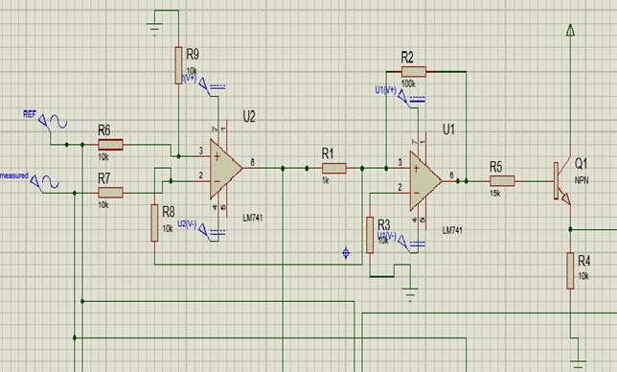

*Fig. 4.11 Schmitt Trigger in Proteus*

Hence, as the error crosses the band, the output gate switch signal switches its state which acts as the gate signal to the inverter. In actual hardware, Fig. 4.12 shows the actual response of Schmitt Trigger output for inverter gate signal.

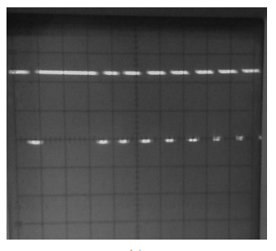

*Fig. 4.12 Actual Schmitt Trigger output for Inverter gate signal in CRO*

**4.6 INVERTER**

**4.6.1 MOSFETS (IRF540)**

The metal–oxide–semiconductor field-effect transistor (MOSFET) is a type of transistor used for amplifying or switching electronic signals. MOSFET is a three-terminal device viz. source (S), gate (G), and drain (D). The main advantage of a MOSFET over a regular transistor is that it requires very little current to turn on (less than 1mA), while delivering a much higher current to a load (10 to 50A or more).If VGS(gate-to-source voltage) is 0 volts, the transistor is turned OFF, and there is no conduction between drain and source. If VGS is applied with some voltage, transistor allows the current to flow from drain to source. MOSFET is operated at cut-off region in order to use it as a switch.

For our application, IRF540 is used as shown in Fig. 4.14. It is easily available in market. IRF540 have maximum rating of drain to source current 33 A for continuous operation. It can with stand 100 volts across drain to source. When operated in cut-off region it provides static drain to source resistance of 44 mΩ.

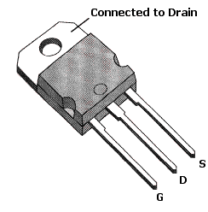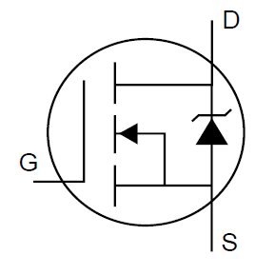

*Fig. 4.14 IRF540 IC and MOSFET’s Symbol*

**4.6.2 DRIVER IC**

In case of three phase Inerter, three legs containing six MOSFETs needs to be switched ON and OFF according to the gate pulses generated by hysteresis current controller. Switching of MOSFETs could be done by supplying 10 to 15 volts across gate to source. For high frequency application the driving of MOSFETs gets complicated. A simple solution to the switching of MOSFETs could be to use a driver IC, which makes the circuit compact as well as robust. Among all the ICs IR2110 is most widely used for industrial applications as in *Fig. 4.15*. The IR2110 are high voltage, high speed power MOSFET and IGBT drivers with independent high and low side referenced output channels. The floating channel can be used to drive an N-channel power MOSFET or IGBT in the high side configuration. Floating channel designed for bootstrap operation. They are built to tolerate to negative transient voltage and they are dV/dt immune too.

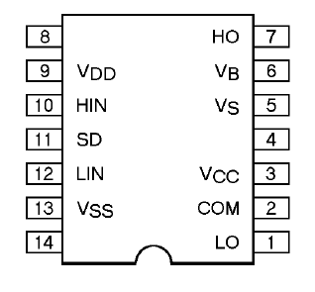

*Fig 4.15* *IR2110 IC*

IR2110 is supplied with logic supply, low and high side supply voltages. Logic voltage could be between 3 to 20 volts and low and high side supply voltage could be between 10 to 20 volts. In our application logic supply voltage is 5 volts and low and high side supply voltage is 15 volts. Hence, TTL logic signals are taken as input to drive the MOSFETs. Bootstrap capacitors are chosen according to the frequency of the gate pulses. It is recommended to use 0.47 uF capacitor for frequency above 5 kHz. For our application boot strap capacitor of 22 uF is used. *Fig. 4.16* illustrates the circuit diagram of MOSFET driver.

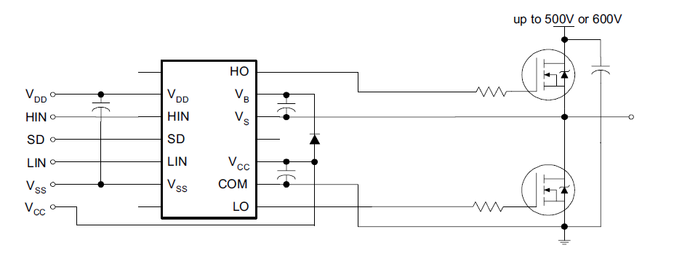

*Fig 4.16 Circuit diagram of MOSFT driver*

**4.7 OVERALL HARDWARE RESULTS**

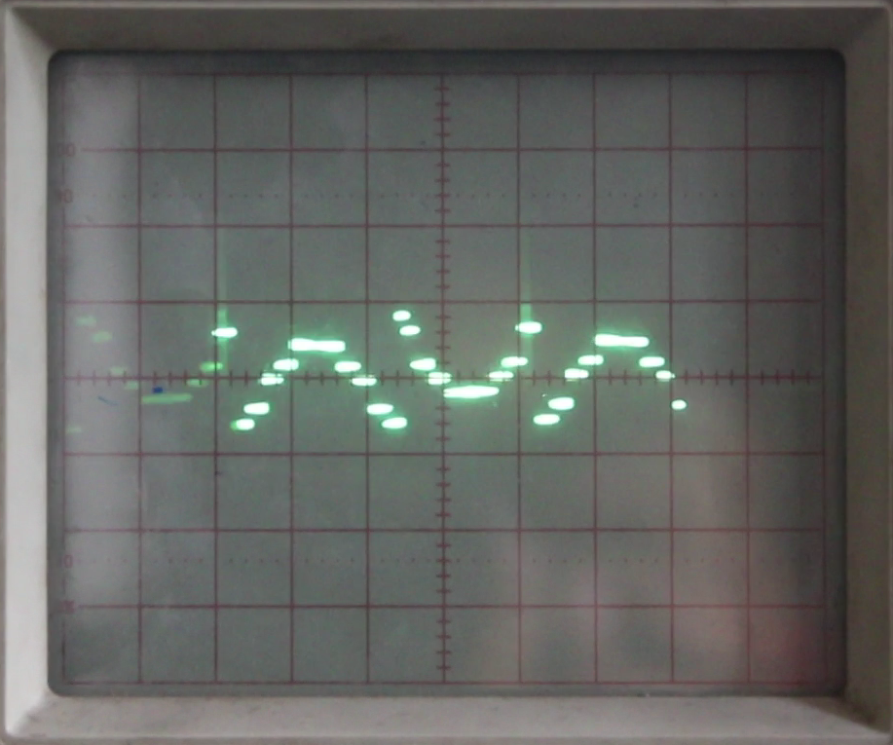

*Fig. 4.17(a) Waveform of calculated phase current of phase-a*

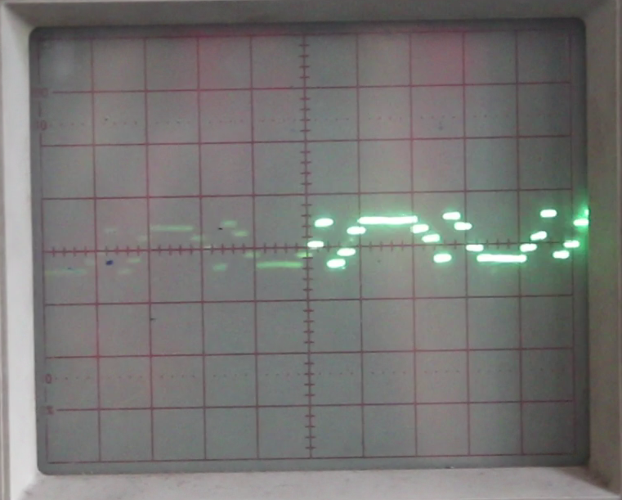

*Fig. 4.17(b) Waveform of calculated phase current of phase-b*

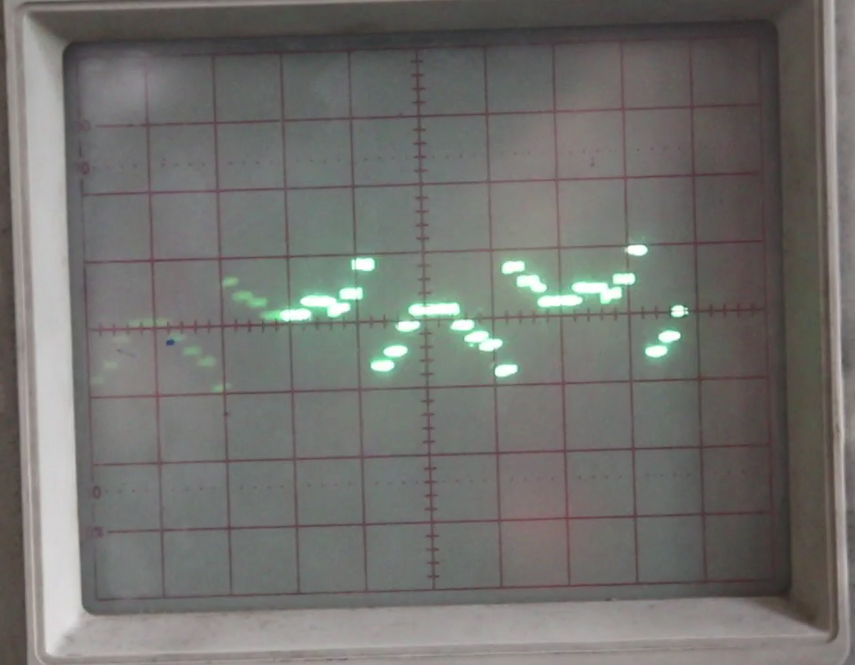

*Fig. 4.17(c) Waveform of calculated phase current of* *phase-c*

*Fig. 4.18(a) Waveform of injected current of phase-a*

*Fig. 4.18(b) Waveform of injected current of phase-b*

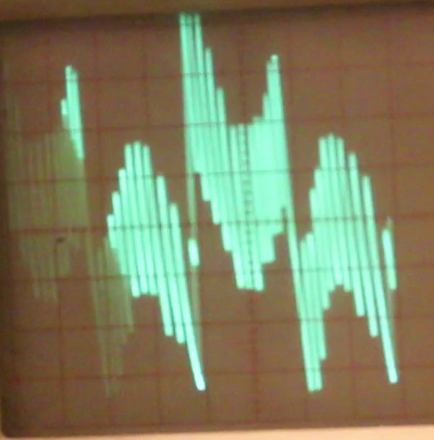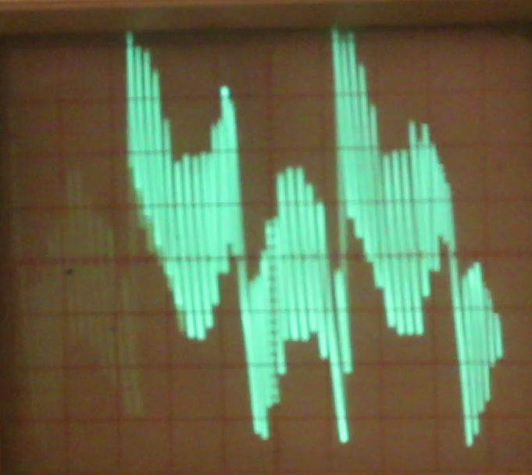

*Fig. 4.18(c) Waveform of injected current of phase-c*

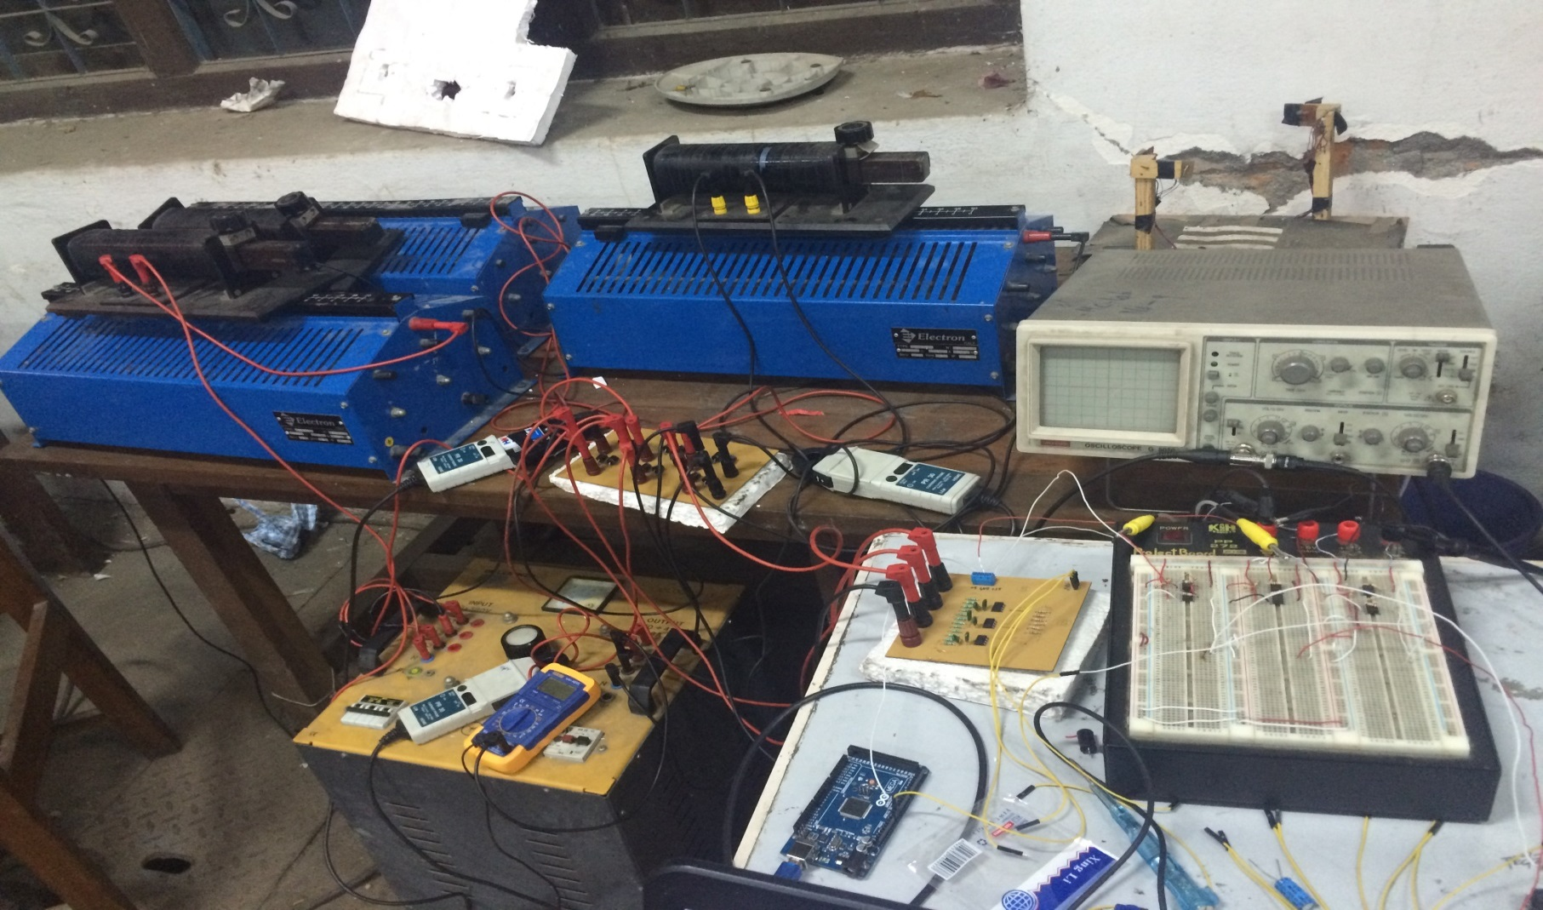

R-L load

3-phase Vari-ac

3- phase rectifier

Current offset

Voltage

sensor

Hall effect current sensor

Arduino 2560

*Fig. 4.17 Overall reference current calculation circuit*

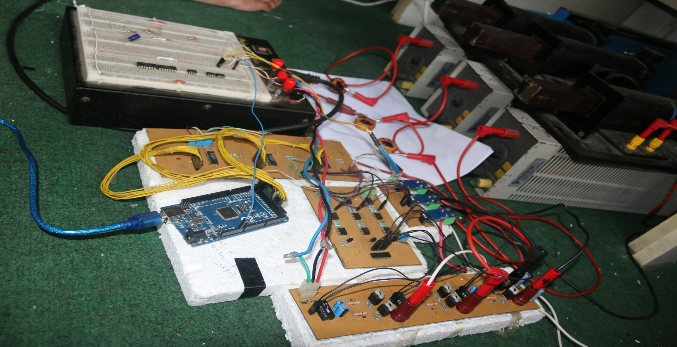

Arduino 2560

Module

Inverter

Hysteresis current controller

Load

Current Sensors

DAC cicuit

Coupling

Inductor

*Fig. 4.4 Overall current Injection circuit*

# REFERENCES

[1] Rashid,M. H. (Ed). Power Electronics Handbook: Devices,Circuits, and

Applications,3rd Ed, Butterworth-Heinemann Publisher,2011, pp.1193-1228.

[2] H. Akagi, Y. Kanazawa, and A. Nabae, “Generalized Theory of Instantaneous Reactive

Power and Its Applications,” *Transactions of the IEE-Japan,* Part B, vol. 103, no.7,

1983,pp,483-490(in Japanese).

[3]Bhimsingh, Kamal Al-Haddad, and Ambrish Chandra, “A Review of Active Filters for

Power Quality Improvement,” *IEEE Transactions on Industrial Electronics, vol. 46, no.*

*5, October 1999*

[4]María Isabel Milanés Montero, Enrique Romero Cadaval, and FermínBarrero

González, “Comparison of Control Strategies for Shunt ActivePower Filters in Three-

Phase Four Wire Systems,” *IEEE Transactions on Power Electronics, vol. 22, no.*

*1,January 2007*

[5]E. Clarke, *Circuit Analysis of A-C Power Systems, Vol. I-Symmetrical and Related*

*Components*, Wiley, 1943.

[6]R. L. A. Ribeiro, T. O. A. Rocha, R. M. Sousa, E. C. dos Santos Jr., and A. M. N. Lima, “A

Robust DC-Link Voltage Control Strategy to Enhance the Performance of Shunt Active

Power Filters without Harmonic Detection Schemes,” *IEEE Transactions on Industrial*

*Electronics, 2013*

[7]*IEEE Recommended Practices and Requirement for Harmonic Control in Electrical*

*Power System,*IEEE Std. 519-1992, 1992.

**APPENDIX – I**

**MATLAB Programs Used**

The MATLAB programs that were used for the simulation of the system model are

shown below:

## Calculation of butter-worth filter

clc;

rp= 3;%passband ripple

wp= 2*pi*50;%passband frequency

ws= 2*pi*1;%stopband frequency

fs= 3000;%sampling frequency

w1=2*50/fs;

w2=2*1/fs;

[n,wn]=buttord(wp,ws,rp,50,'s');

[z,p,k]=butter(n,wn,'high','s');

[num,den] = zp2tf(z,p,k);

sys=tf(num,den)

## Design of Digital Filter

function y = fcn(u,sample_instant)

%#codegen

persistent x2 x3 y1 y2 y3;

if isempty(x2)

x2=0;

end

if isempty(x3)

x3=0;

end

if isempty(y2)

y2=0;

end

if isempty(y3)

y3=0;

end

if isempty(y1)

y1=0;

end

if (sample_instant==0)

x1=u;

y1 = x1-1.999*x2+0.999*x3+1.947*y2-0.9487*y3;

x3=x2;

x2=x1;

y3=y2;

y2=y1;

end

y=y1;

end

**APPENDIX – II**

**AVR ATmega8 Source Code on Atmel Studio®**

# Source code for Manual current injection

float in;

unsigned long Mils = millis();

float a=0,b =0,c =0;

byte multiplier = 50;

void setup() {

Serial.begin(57600);

DDRA = B11111111;

DDRC = B11111111;

DDRL = B11111111;

}

void loop() {

for (in = 0; in < 6.283; in += (multiplier * 0.006283))

{

while ((millis() - Mils) < 1) {};

Mils += 1;

if(in<=3.14) a= 131.5;

else a=123.5;

if(in>=1.047&&in<=4.1887) c= 122.5;

else c=130.5;

if(in>=2.094&&in<=5.2355) b= 130.5;

else b=122.5;

PORTA =a-sin(in)*4;

PORTC = b-sin(in-2.094)*4;

PORTL = c-sin(in-4.1887)*4;

}

}

# Source code for Reference current calculation

#include <TimerOne.h>

const unsigned char PS_16 = (1 << ADPS2);

const unsigned char PS_32 = (1 << ADPS2) | (1 << ADPS0);

const unsigned char PS_64 = (1 << ADPS2) | (1 << ADPS1);

const unsigned char PS_128 = (1 << ADPS2) | (1 << ADPS1) | (1 << ADPS0);

//Analog pin Config

const int voltage1 = A1;

const int voltage2 = A2;

const int voltage3 = A3;

const int current1 = A4;

const int current2 = A5;

const int current3 = A6;

const int sampleTime = 1000;

float v1,v2,v3,c1,c2,c3 ,valpha,vbeta,Ialpha;

float Ibeta,Inull,Ic1,Ic2,Ic3,Ica,Icb,Icc,P,Q,Posc;

float x1=0;

float x2=0;

float x3=0;

float y1=0;

float y2=0;

float y3=0;

boolean StartCalc = true;

void setup() {

Serial.begin(115200);

DDRA = B11111111;

DDRC = B11111111;

DDRL = B11111111;

Timer1.initialize(sampleTime);

Timer1.attachInterrupt( timerIsr );

// remove existing prescaler of ADC

ADCSRA &= ~PS_128;

// choose a new prescaler

ADCSRA |= PS_16;

}

void loop() {

//when interrupt is called

while(StartCalc == true){

//measure the value of instantaneous voltage and current

v1 = (float)((analogRead(voltage1)*0.00978-5.07)*4.54);

v2 = (float)((analogRead(voltage2)*0.00978-5.07)*4.54);

v3 = (float)((analogRead(voltage3)*0.00978-5.07)*4.54);

c1 = (float)((analogRead(current1)-505)*0.0049*10);

c2 = (float)((analogRead(current1)-505)*0.0049*10);

c3 = (float)((analogRead(current1)-505)*0.0049*10);

valpha = 0.8164*(v1-0.5*v2-0.5*v3);

vbeta = 1.4142*(0.5*v2-0.5*v3);

Ialpha = 0.8164*(c1-0.5*c2-0.5*c3);

Ibeta = 1.4142*(0.5*c2-0.5*c3);

Ic3 = 0.5773*(c1+c2+c3);

P = valpha*Ialpha+vbeta*Ibeta;

Q = -(vbeta*Ialpha - valpha*Ibeta);

Posc = -Filter(P);

Ic1 = (-1/(sq(valpha) + sq(vbeta)))*((Posc*valpha)+(Q*vbeta));

Ic2 = (-1/(sq(valpha) + sq(vbeta)))*((Posc*vbeta)-(Q*valpha));

Ica = 0.8164*(Ic1+(0.7072*Ic3));

Icb = 0.8164*((-0.5*Ic1)+(0.866*Ic2)+(0.7072*Ic3));

Icc = 0.8164*((-0.5*Ic1)-(0.866*Ic2)+(0.7072*Ic3));

StartCalc = false;

}

PORTA = (Ica*0.5+2.5)*255/5;

PORTC = (Icb*0.5+2.5)*255/5;

PORTL = (Icc*0.5+2.5)*255/5;

}

//ISR Timer Routine

void timerIsr()

{

StartCalc=true;

}

float Filter(float u)

{

x1=u;

y1 = x1-1.994*x2+0.9941*x3+1.842*y2-0.8538*y3;

x3=x2;

x2=x1;

y3=y2;

y2=y1;

return y1;

}